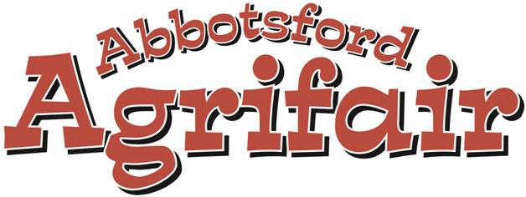

2023

4-H

Scholarship
Name:

Last Name: First Name:

Home Address: City:

Postal Code: Phone Number:

Mailing Address (If different from above):

City: Postal Code:

Email:

Name of Parent or Legal Guardian (if applicable):

Name of University or School You Plan to Attend:

Province: Date You Plan to Enroll:

Name of Program Applied for:

Date of High School Graduation:

4-H ACTIVITIES
Name of club(s) in which you are presently or previously registered in:

Approximate number of members involved:

Name and contact information of your club leader(s) – previous leader(s) if present leader is new:

Number of years as a 4-H member:

List projects you have completed include number of years for each:

Project Year

Have you completed a Senior Management Project? YES / NO

If so what kind:

Number of years:

List any major 4-H awards you have received, include club, district and provincial:
Example: Provincial Club Week, national travel opportunities, skill certificates, medals, pins etc.

Year: Award:

Year: Award:

Year: Award:

Year: Award:

Year: Award:

Year: Award:

List the Office Positions that you have held in 4-H organizations:

Year Office Year Office

List activities other than 4-H such as: other agricultural involvement, community, church, school, youth organizations, sports, hobbies etc.

Year: Activities:

Year: Activities:

Year: Activities:

Year: Activities:

Year: Activities:

Year: Activities:

Year: Activities:

Year: Activities:

I declare that I was a showing member of the 2019, 2020, or 2022 Abbotsford Agrifair, and I have filled out this application to the best of my knowledge.
Signature of Applicant: Date:

Please contact office to set up your Photo Op slot. Please attach a Reference Letter.
Please attach any other necessary information you feel our Scholarship judges may need.

